1D-Sod shock tube

##### The declaration of problem

is a common test for the accuracy of [computational fluid codes](https://en.wikipedia.org/wiki/Computational_fluid_dynamics), like [Riemann solvers](https://en.wikipedia.org/wiki/Riemann_solver), and was heavily investigated by Sod in 1978.

The test consists of a one-dimensional [Riemann problem](https://en.wikipedia.org/wiki/Riemann_problem) with the following parameters, for left and right states of an [ideal gas](https://en.wikipedia.org/wiki/Ideal_gas).

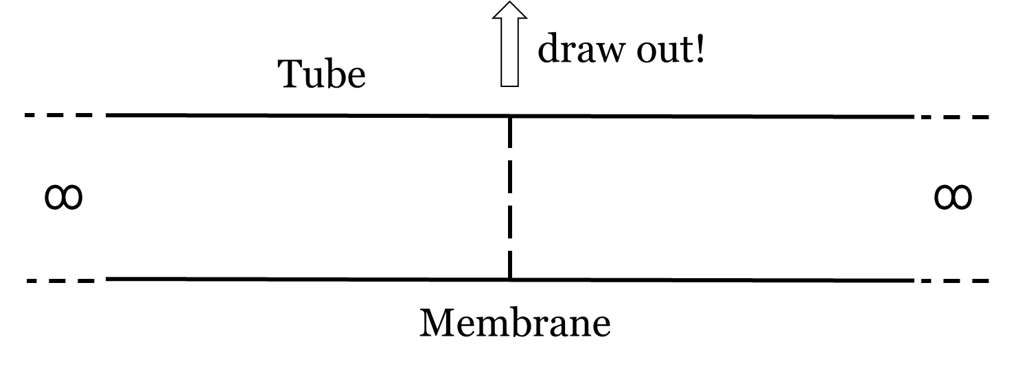

$$\left(\begin{matrix}ρ_{L}=1.0 \\ P_{L}=1.0 \\ v_{L}=0.0\end{matrix}\right) = \left(\begin{matrix}ρ_{R}=0.125 \\ P_{R}=0.1 \\ v_{R}=0.0\end{matrix}\right)$$

where

* $ρ$ is the density
* P is the pressure
* v is the velocity

The time evolution of this problem can be described by solving the [Euler equations](https://en.wikipedia.org/wiki/Euler_equations), which leads to three characteristics, describing the propagation speed of the various regions of the system. Namely the rarefaction wave, the contact discontinuity and the shock discontinuity. If this is solved numerically, one can test against the analytical solution, and get information how well a code captures and resolves shocks and contact discontinuities and reproduce the correct density profile of the rarefaction wave.

<https://en.wikipedia.org/wiki/Sod_shock_tube>

##### The result of *sod shock tube* problem

Analytic result is available on the Wikipedia. For convenience, we just download the picture. If we want to justify the numerical result, we only need to compares two picture.

The first is the analytic result, while the second is the numerical result acquired by NND.

It is apparent that the two results are almost one.

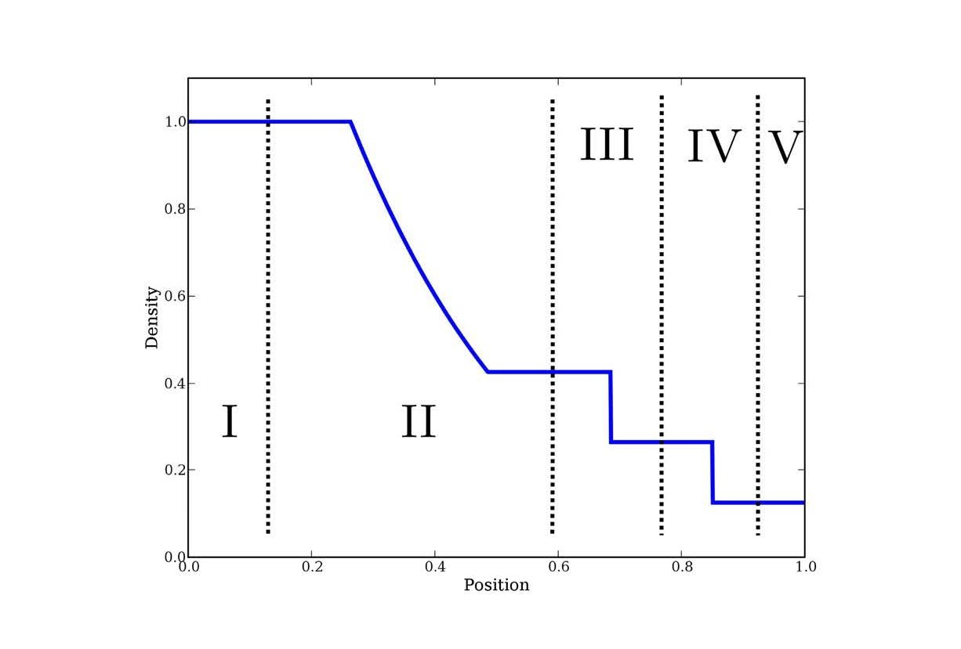





《Sod激波管及前台阶流动计算报告》理论解表达见<https://wenku.baidu.com/view/7519f4f3c0c708a1284ac850ad02de80d4d806f5.html>